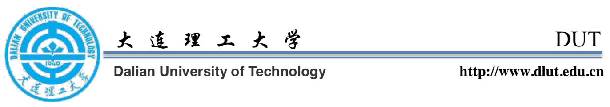

Topic: Recommendation Letter from Lei WANG for Wenbo ZHAO

To Whom It May Concern,

This recommendation is written for Wenbo ZHAO, one of my favorite students, to apply for the master’s programs that he is pursuing. Wenbo has been well cultivated in the past undergraduate studies, and is exceptional in both theoretical and practical. I would recommend him without any reservation as his instructor and supervisor.

When it was Sep. 2017, Wenbo showed his proactivity toward research as early as a freshman, and joined my laboratory. He is very hard working and strict with himself at that time, reporting back his ideas and work. From my feedback, he would absorb my thoughts on work or life, learn about what he was lacking, and then apply his gains to his later tasks.

Accumulated adequate fundamental skills of research, he was arranged to be involved in several projects under my instruction. From these projects, I inspected him more holistically. As a team member, Wenbo tried to exert all his strengths and often thought about the overall progress of the team.

For example, in the research High Robust Indoor Positioning System Based on AOA, I saw his ability of time management. He was good at subdividing his responsibilities into small tasks, writing down reminders on the phone, and then finishing the tasks one by one before the deadline that he set for himself. When it comes to teamwork, Wenbo always shared his creative ideas relative to both his part and others’ parts, and then put the ideas into practice along with other members and me – his teamwork spirit was contributive for the awards that we got.

Consequently, Wenbo ZHAO, an exceptional research assistant, is worth my recommendation. I sincerely recommend him without any reservation for the above reasons, and hope that his excellence will continue in your prestigious platform!

Best regards,

Wang, Lei (Ray) Ph.D., Professor 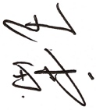

Vice Dean, School of Software

Dalian University of Technology, China, 116020

Tel: +86 411 6227 4394

Email: lei.wang@dlut.edu.cn, lei.wang@ieee.org

http://faculty.dlut.edu.cn/leiwang